**Product labels**

## Product

|  |  |
| --- | --- |
| **Catalogue number** | **Name** |
| BVD480 | BVD – MD IgG ELISA |

## Outer labels (examples)

### LABEL 1

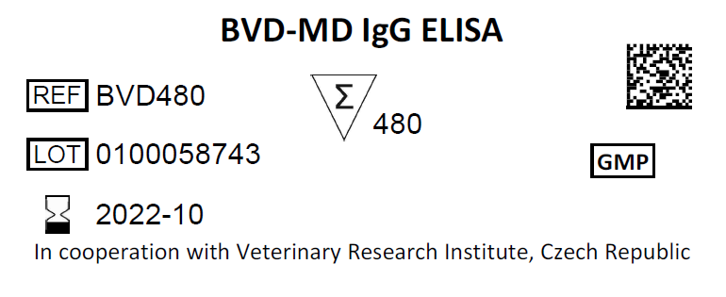

### LABEL 2

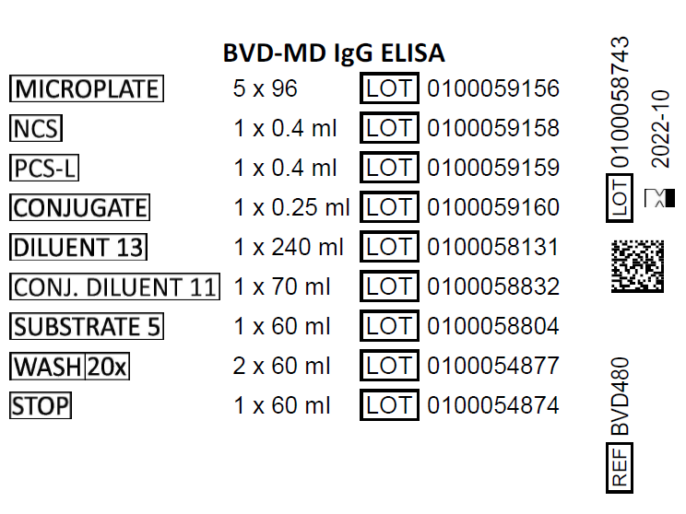

## LABEL 3

## cid:image006.jpg@01D823EF.CE560750

## Inner labels (examples)

### MICROPLATE

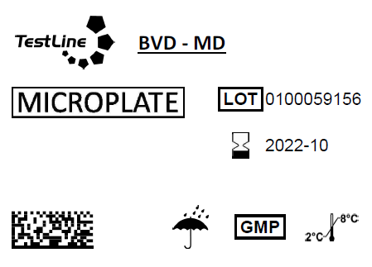

### NCS

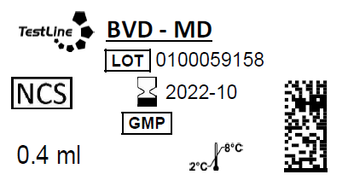

### PCS-L

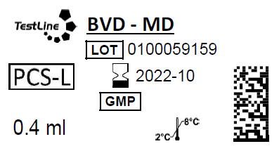

### CONJUGATE

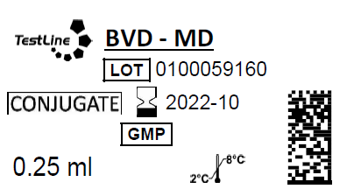

### DILUENT 13

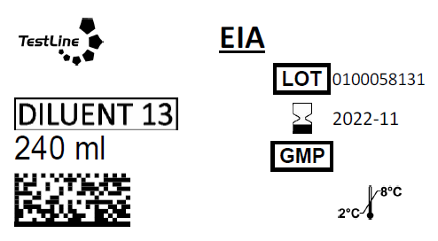

### CONJ. DILUENT 11

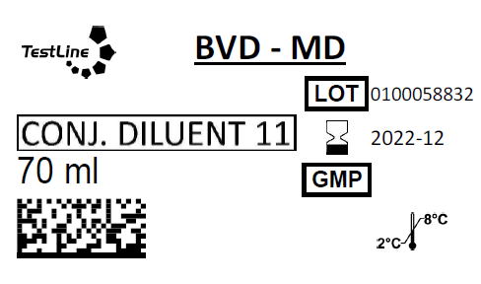

### SUBSTRATE 5

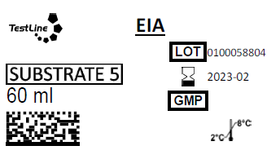

### WASH SOLUTION

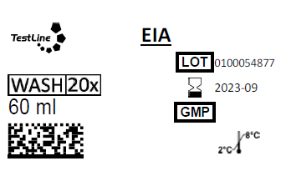

STOP SOLUTION

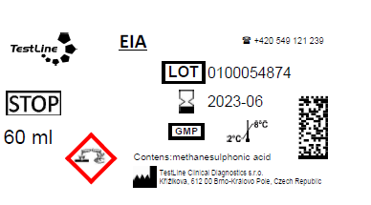

## Used symbols

